Parse:

//declare variables, malloc space for args_arr

int i = 0;

char** args_arr = malloc(MAX);

//set arg = to the result of strtok on input using " "

char* arg = strtok(input, " ");

//while loop to fill args_arr[i] with with each arg being the return value of strtok null and " "

while(arg != NULL){

args_arr[i] = arg;

arg = strtok(NULL, " ");

i++;

}

args_arr[i] = NULL;

return args_arr;

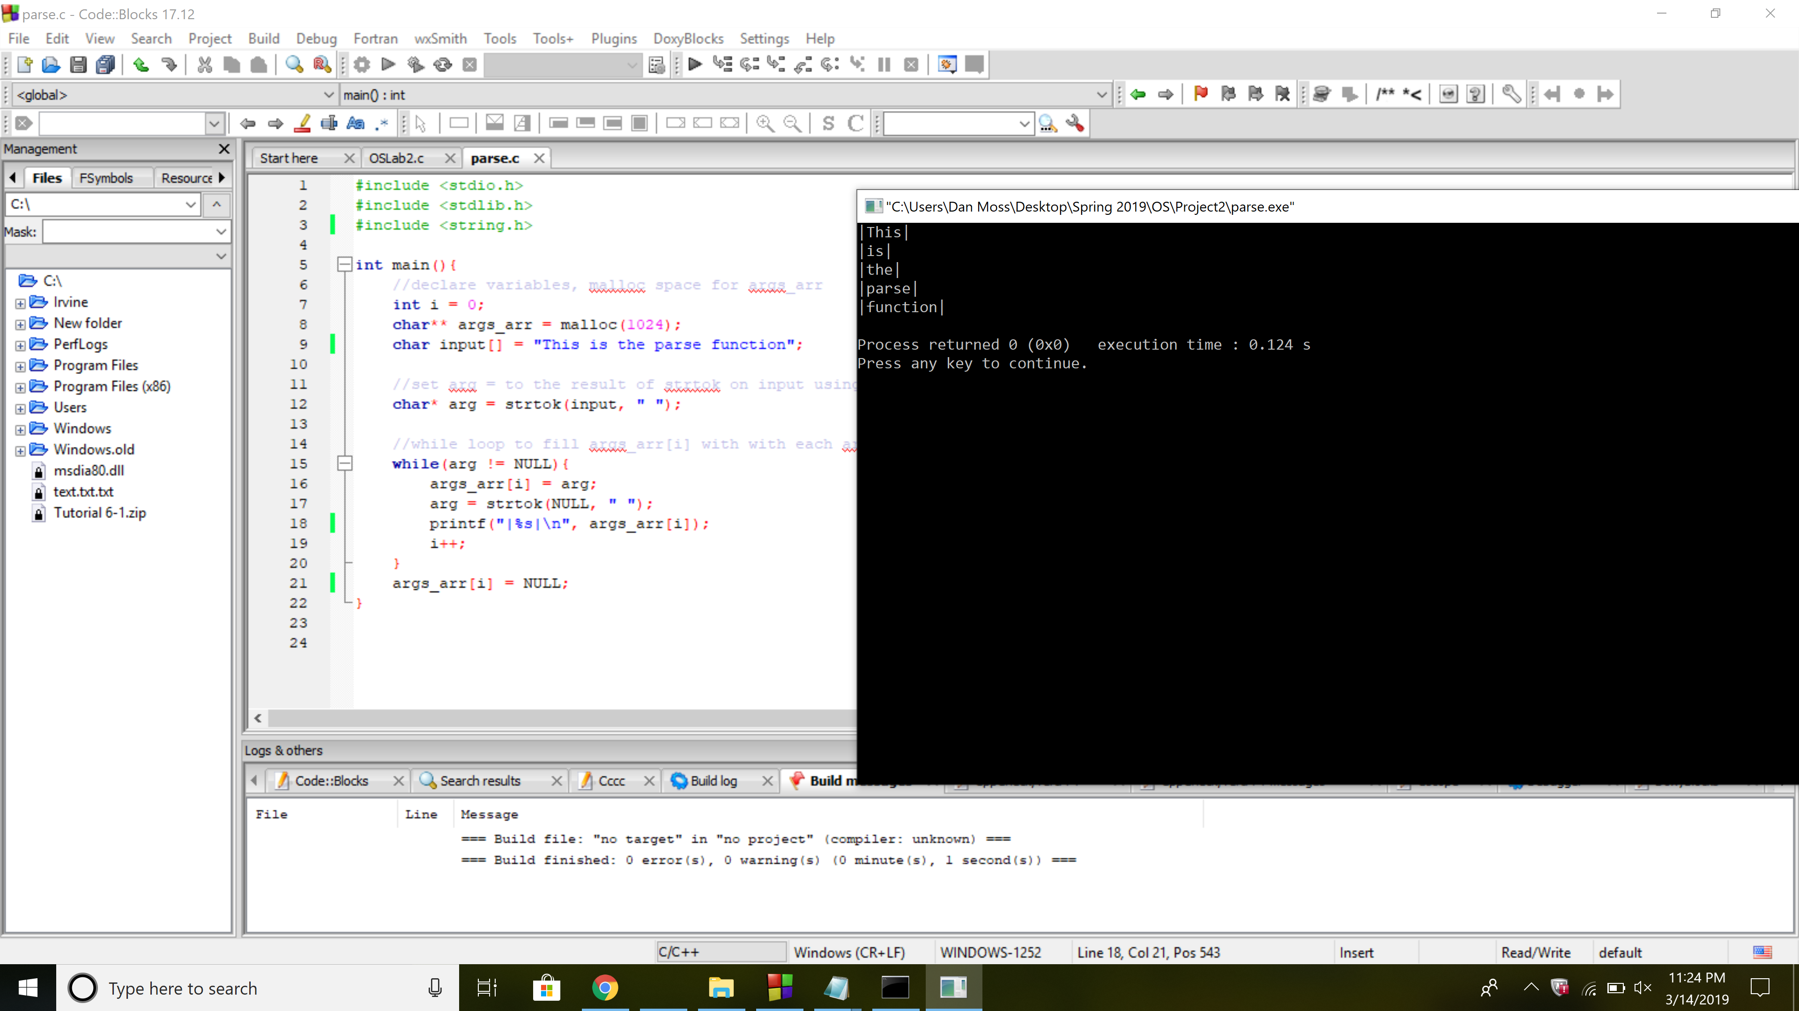

External Exec:

if(built_in == 0) {

//declare process id

pid_t pid;

//call fork() and the return value is the pid

pid = fork();

//if the pid is less than zero there was an error

if(pid < 0) {

printf("Error forking\n");

} //if pid is equal to 0, returned to the newly created process

else if(pid == 0) {

//attempt redirection if necessary

if(isRedirectIn == 1) {

dup2(infile, STDIN_FILENO);

}

if(isRedirectOut == 1) {

dup2(outfile, STDOUT_FILENO);

}

//use execvp to overlay the child process with the new arg

execvp(args[0], args);

exit(0);

}

else{

//if not running in background, wait for child process to terminate

if(background == 0)

waitpid(pid, NULL, 0);

}

}

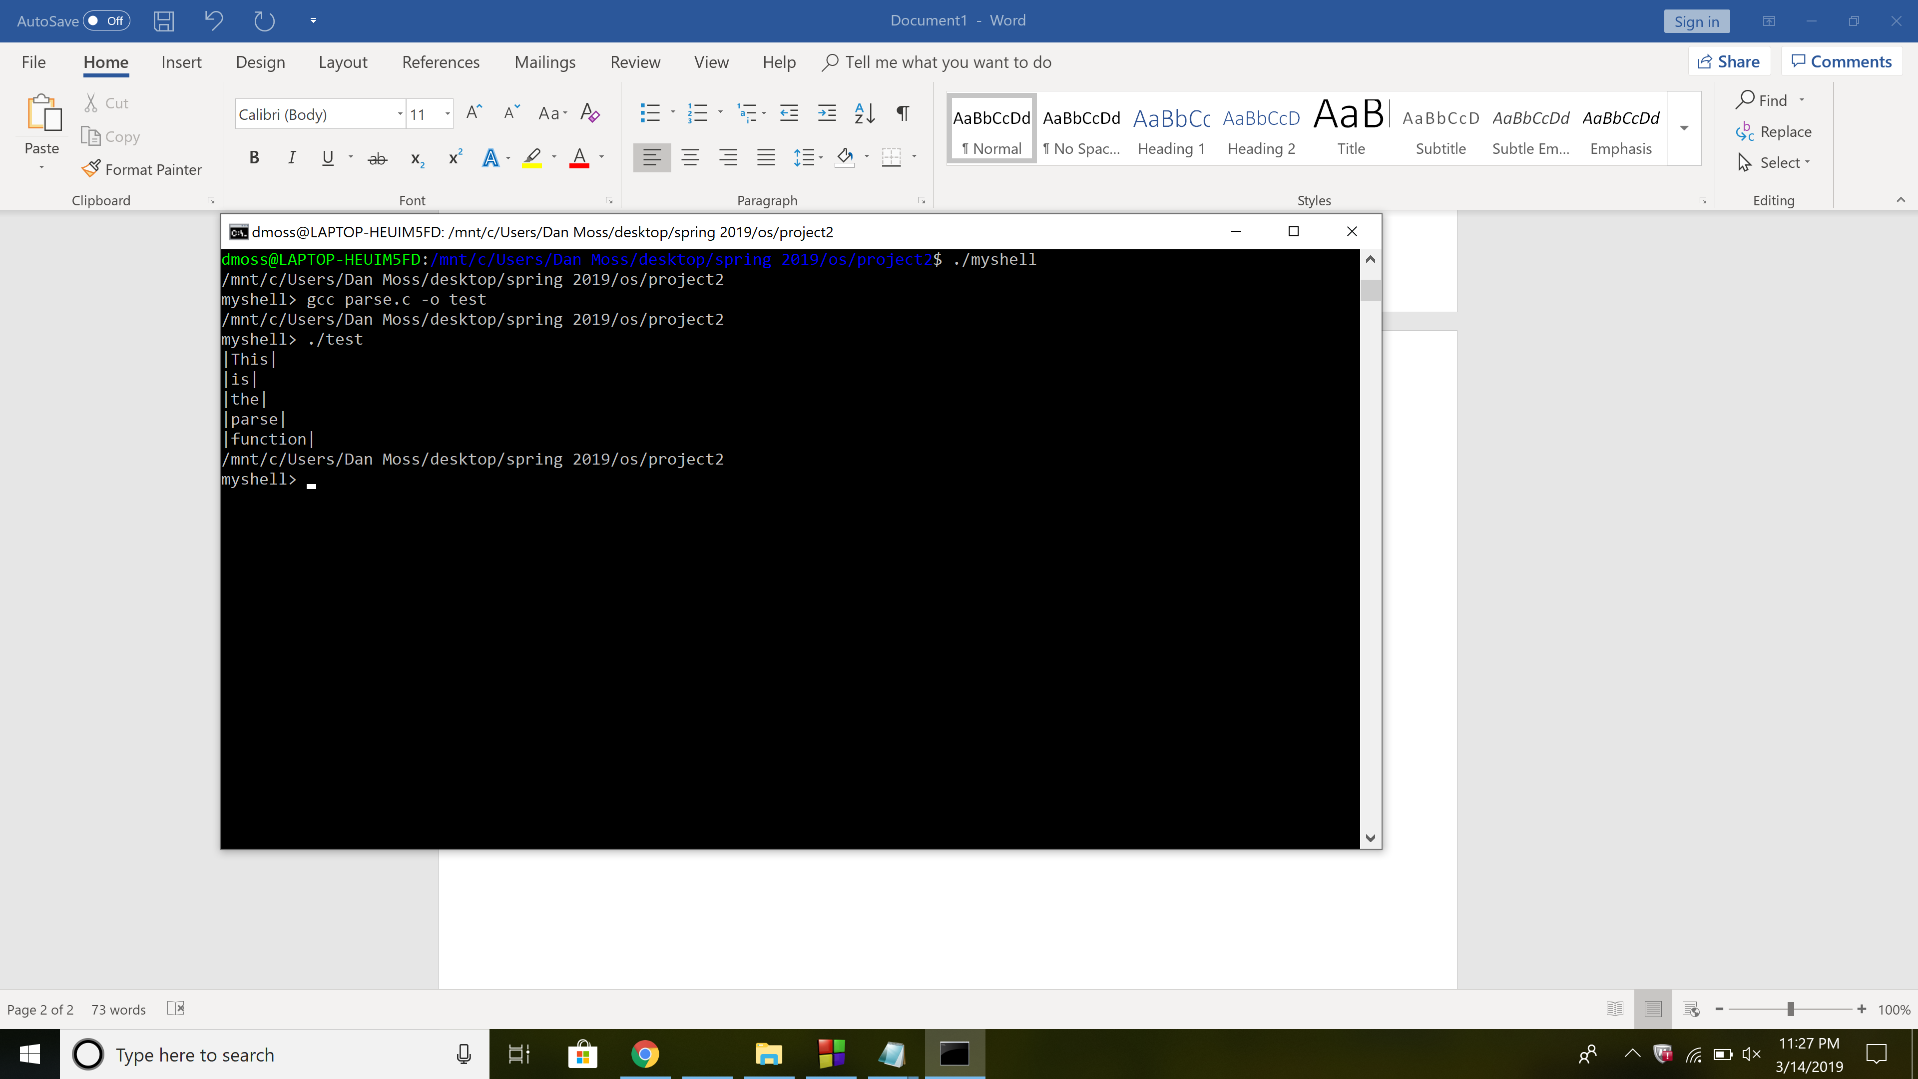

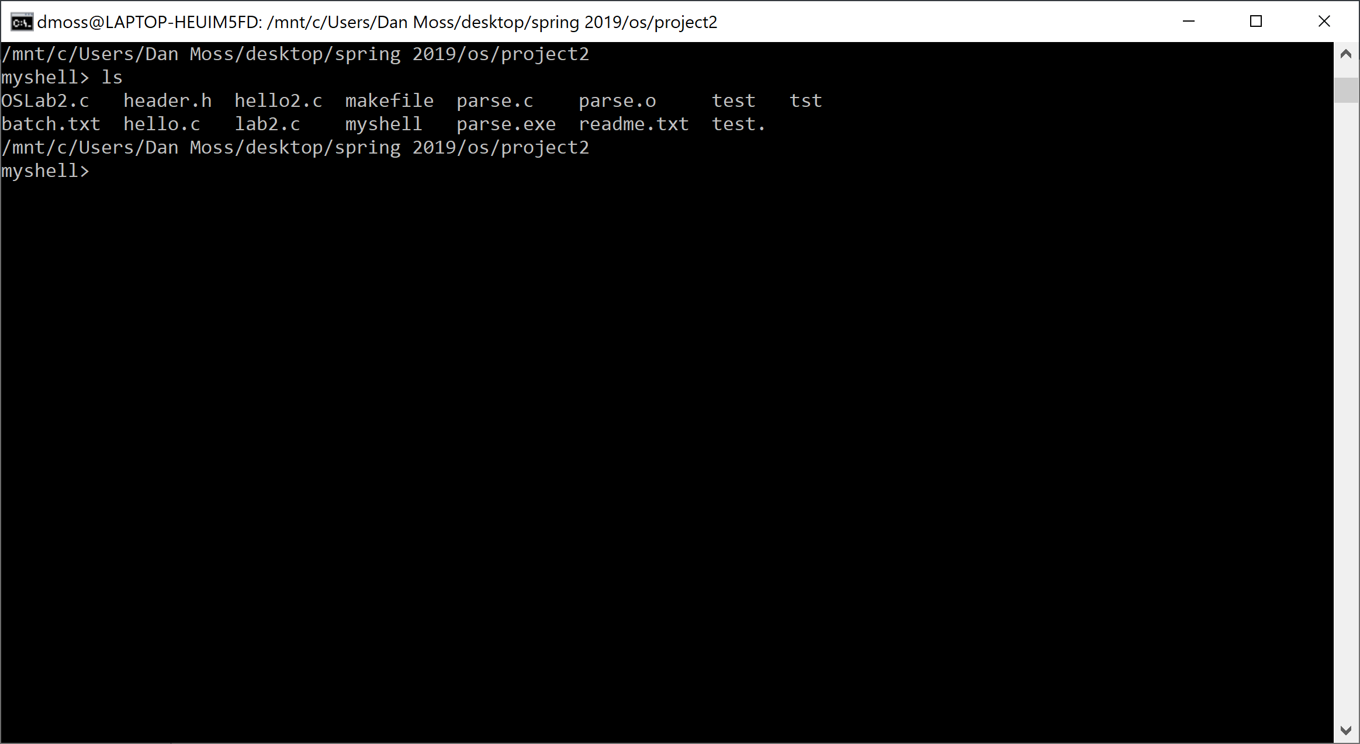

Built in functions:

int pause(){

//while loop waiting for user to press 'enter'

while(getchar() != '/n')

return 1;

}

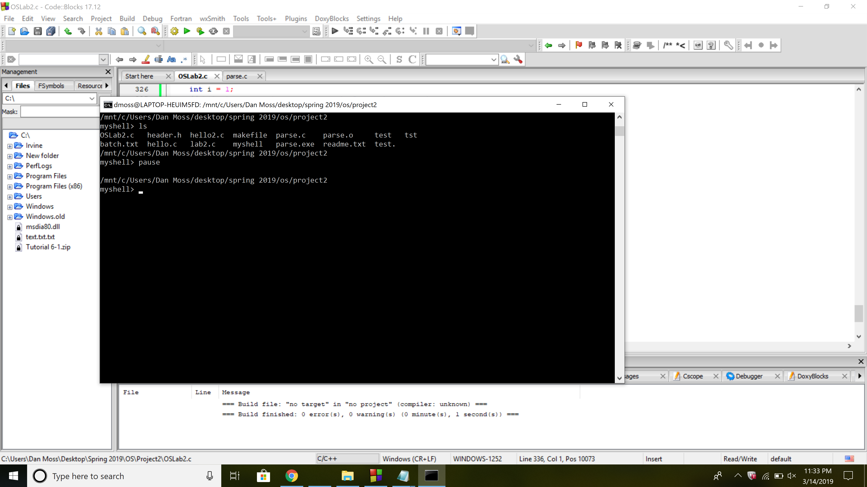

int help(){

FILE *fptr;

char c;

// Open file

fptr = fopen("readme.txt", "r");

if (fptr == NULL) {

printf("Cannot open file \n");

exit(0);

}

// Read contents from file

printf("\n\n\n");

c = fgetc(fptr);

//display contents of the file to output screen

while (c != EOF)

{

printf ("%c", c);

c = fgetc(fptr);

}

printf("\n");

fclose(fptr);

return 1;

}

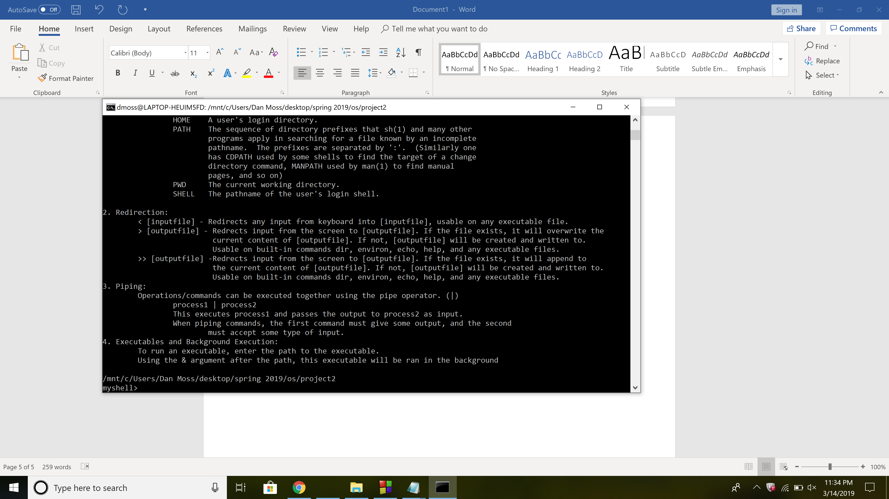

int echo(char** args){

int i = 1;

//while loop to print args entered after echo command

while(args[i] != NULL){

printf("%s ", args[i]);

i++;

}

printf("\n");

return 1;

}

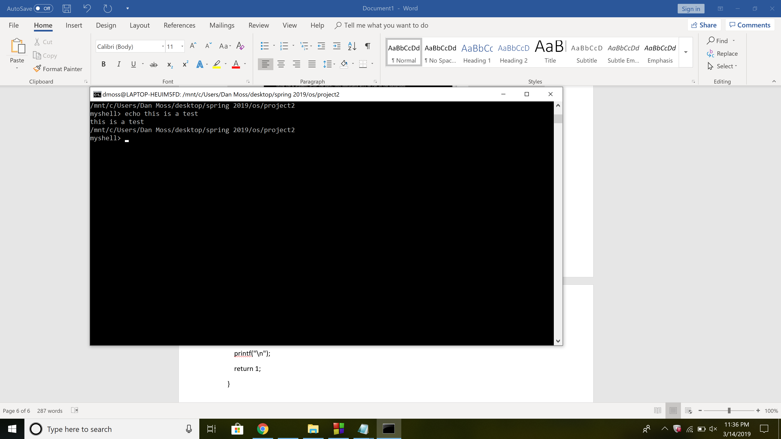

int environ(){

//declare variables and array with the type of environment variables

int numVars = 5;

char* vars[] = {"USER", "HOME", "PATH", "SHELL", "PWD"};

int i;

//for loop to get each environment status for respective variables

for(i = 0; i < numVars; i++) {

const char* v = getenv(vars[i]);

//if there is a valid environment variable, print to screen

if(v != NULL) {

printf("%s=%s\n", vars[i], v);

}

//if not, display error message

else {

printf("Error: Could not find environment variable %s.\n", vars[i]);

}

}

return 1;

}

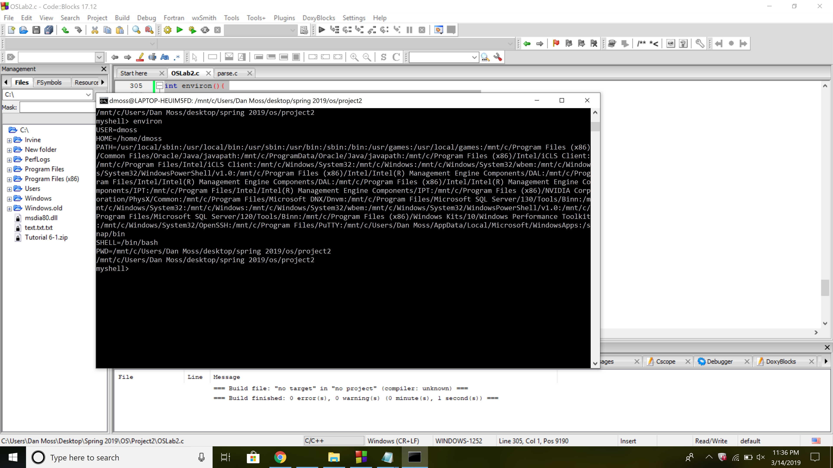

int dir(){

//declare DIR pointer

DIR *dp;

//declare dirent pointer

struct dirent *ep;

//open the directory

dp = opendir("./");

if (dp != NULL){

while (ep = readdir(dp))

puts (ep->d_name);

(void) closedir (dp);

}

else

perror ("Couldn't open the directory");

return 1;

}

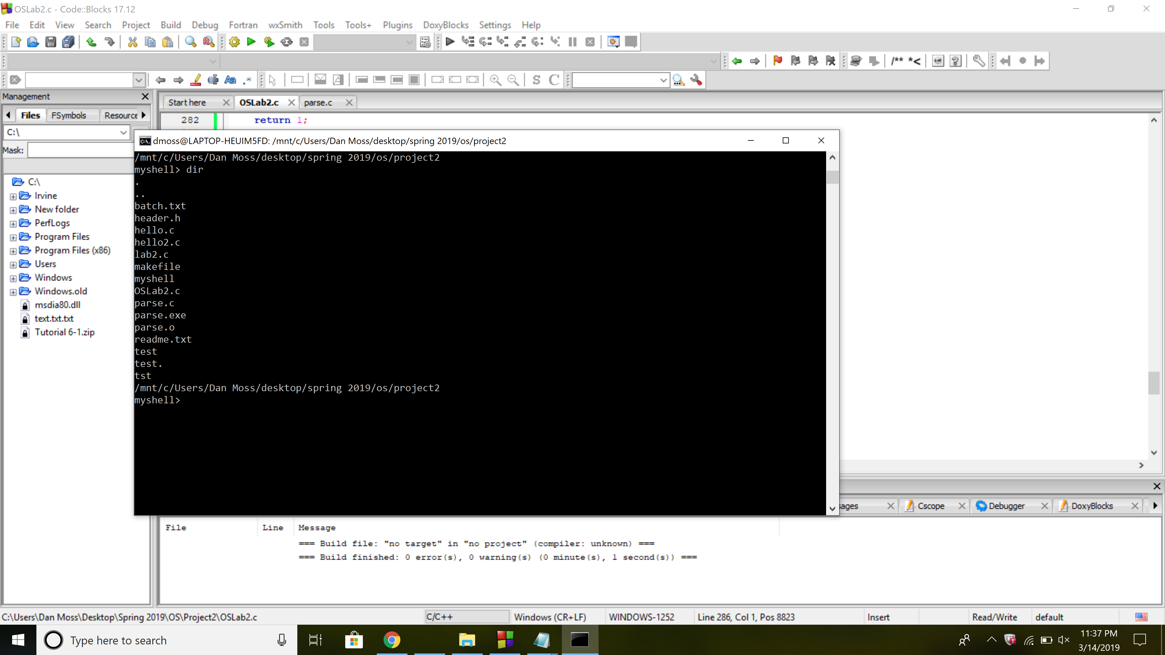

int clr(){

clear();

return 1;

}

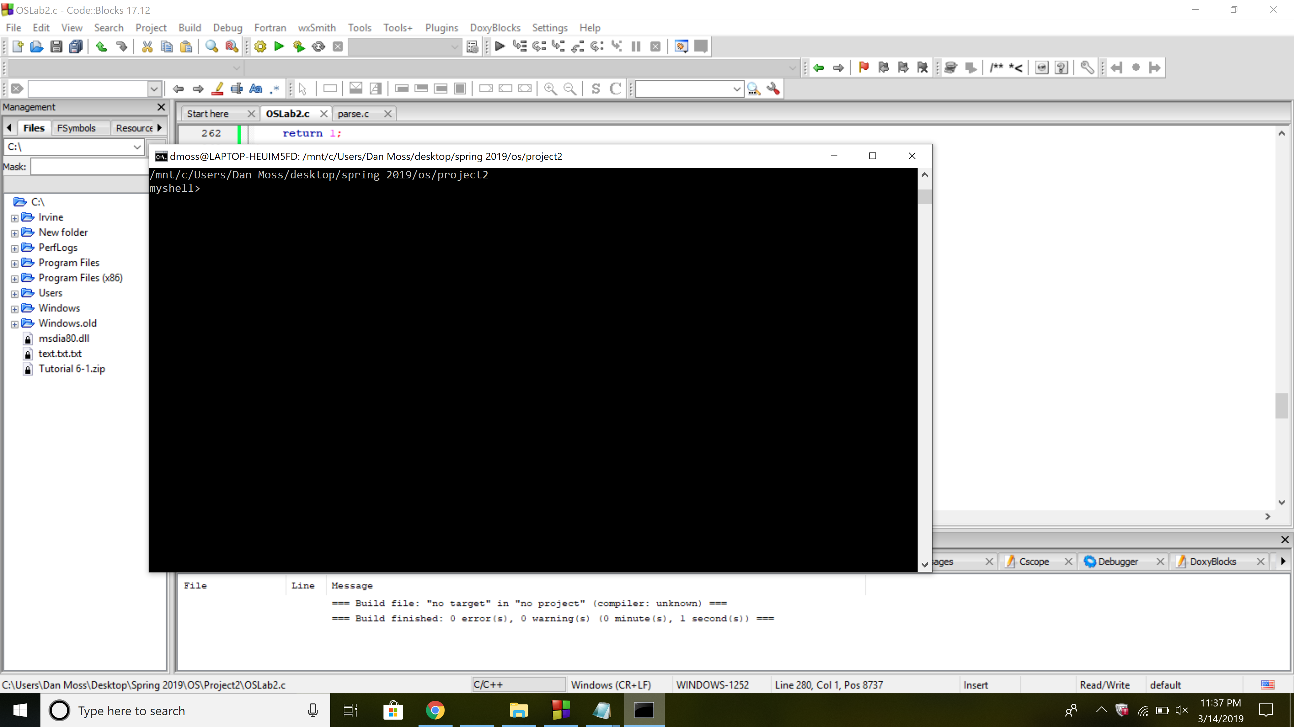

int cd(char** args){

if(chdir(args[1]) != 0) {

printf("No directory found.\n");

}

return 1;

}

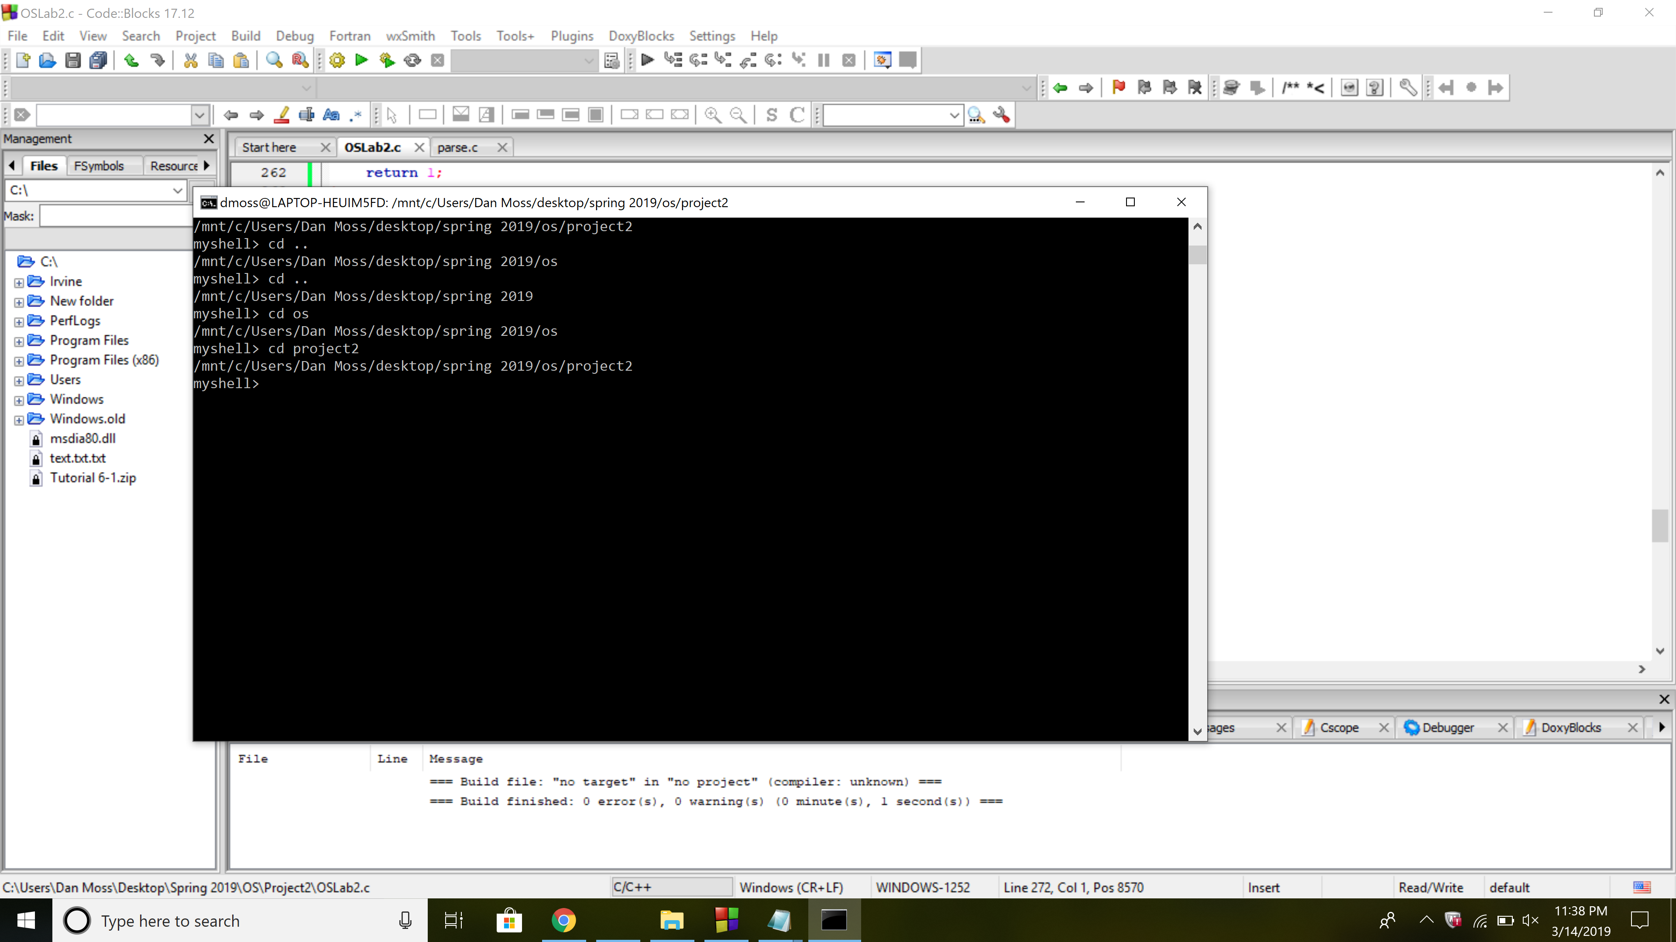

int quit(){

printf("Goodbye.\n");

return 0;

}

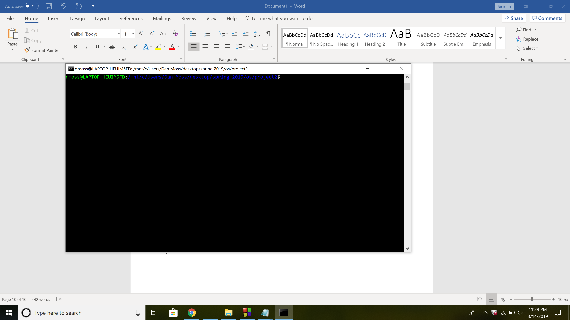

Redirection:

else if(strcmp(args[i], "<") == 0){

infile = open(args[i+1], O_RDONLY);

args[i] = NULL;

isRedirectIn = 1;

}

//comparing each argument to character '>' and execute code if it is detected

else if(strcmp(args[i], ">") == 0){

outfile = open(args[i+1], O_WRONLY | O_TRUNC | O_CREAT, S_IRUSR | S_IRGRP | S_IWGRP | S_IWUSR | O_CLOEXEC);

args[i] = NULL;

isRedirectOut = 1;

}

//comparing each argument to character '>>' and execute code if it is detected

else if(strcmp(args[i], ">>") == 0){

outfile = open(args[i+1], O_WRONLY | O_APPEND | O_CREAT, S_IRUSR | S_IRGRP | S_IWGRP | S_IWUSR | O_CLOEXEC);

args[i] = NULL;

isRedirectOut = 1;

}

//comparing each argument to character '|' and execute code if it is detected

else if(strcmp(args[i], "|") == 0){

args[i] = NULL;

ret = pipefn(&args[--i], &args[++i]);

return ret;

}

i++;

}

//for loop to determine if any of the user commands are built-ins

for(j = 0; j < 8; j++) {

//if statement to check if there is a builtin

if(strcmp(args[0], builtins[j]) == 0){

//save current i/o values

stdinDup = dup(STDIN_FILENO);

stdoutDup = dup(STDOUT_FILENO);

//determine if redirection is needed

if(isRedirectIn == 1) {

dup2(infile, STDIN_FILENO);

}

if(isRedirectOut == 1) {

dup2(outfile, STDOUT_FILENO);

}

//execute the matching built in and set the return flag

ret = (builtinFN[j])(args);

//reset i/o defaults

dup2(stdoutDup, STDOUT_FILENO);

dup2(stdinDup, STDIN_FILENO);

//set built-in flag to one showing a built-in was executed

built_in = 1;

}

}

//if there was no built-in call fork() and execute a file

if(built_in == 0) {

//declare process id

pid_t pid;

//call fork() and the return value is the pid

pid = fork();

//if the pid is less than zero there was an error

if(pid < 0) {

printf("Error forking\n");

} //if pid is equal to 0, returned to the newly created process

else if(pid == 0) {

//attempt redirection if necessary

if(isRedirectIn == 1) {

dup2(infile, STDIN_FILENO);

}

if(isRedirectOut == 1) {

dup2(outfile, STDOUT_FILENO);

}

//use execvp to overlay the child process with the new arg

execvp(args[0], args);

exit(0);

}

else{

//if not running in background, wait for child process to terminate

if(background == 0)

waitpid(pid, NULL, 0);

}

}

//reset built in flag

built_in = 0;

return ret;

}

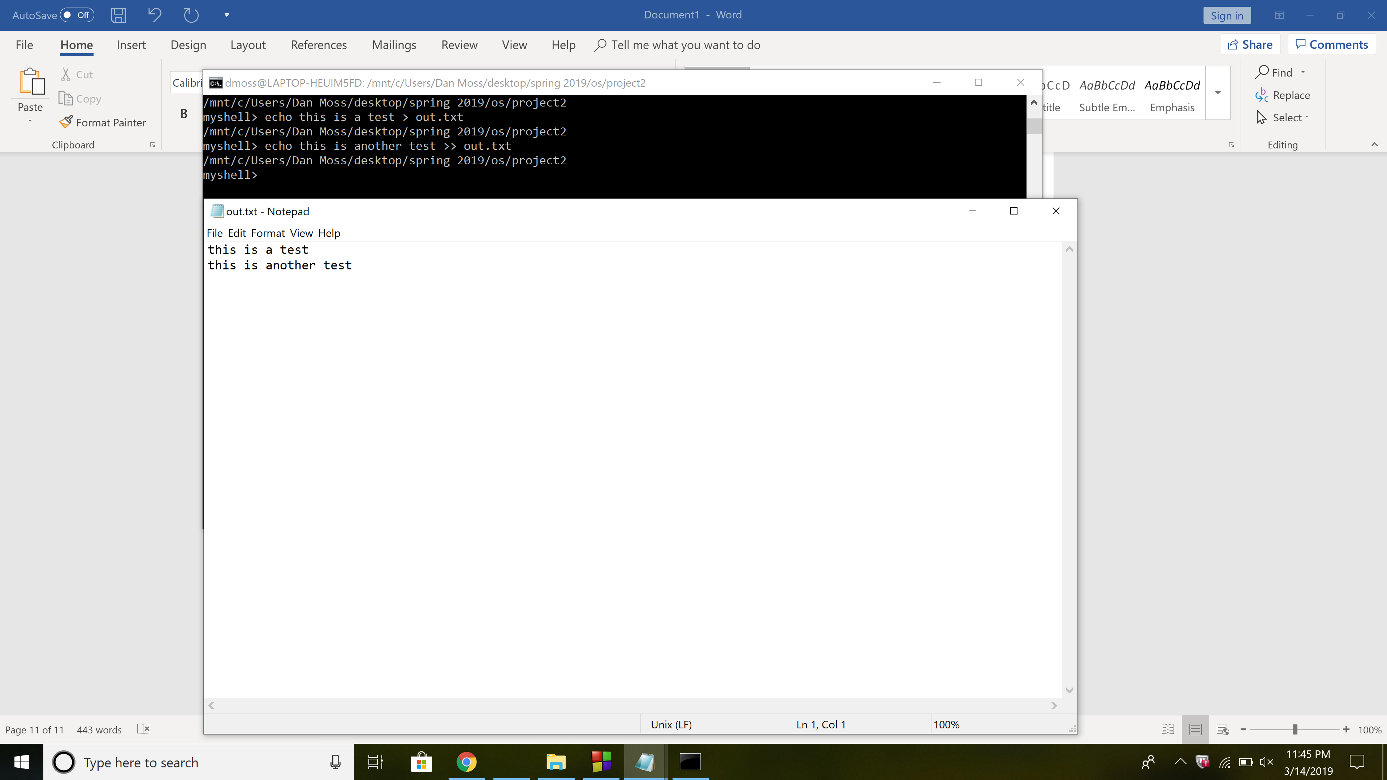

Batch:

void batch(char* filename){

//declare variables

char buffer[50];

char** input_arr;

int size;

//open file 'filename' for reading

FILE *fp = fopen(filename, "r");

//if fp is equal to null, error opening file and quit the program

if(fp == NULL) {

perror("Error in opening file");

exit(0);

}

// reads text until newline

while(fgets(buffer, 254, fp)){

//get rid of trailing newline from fgets statement

buffer[strcspn(buffer, "\r\n")] = 0;

//pass the line from file into the parse and input it into a double pointer char

input_arr = parse(buffer);

//pass input_arr into execute function to execute the command

execute(input_arr);

}

//close the file

fclose(fp);

return 1;

}

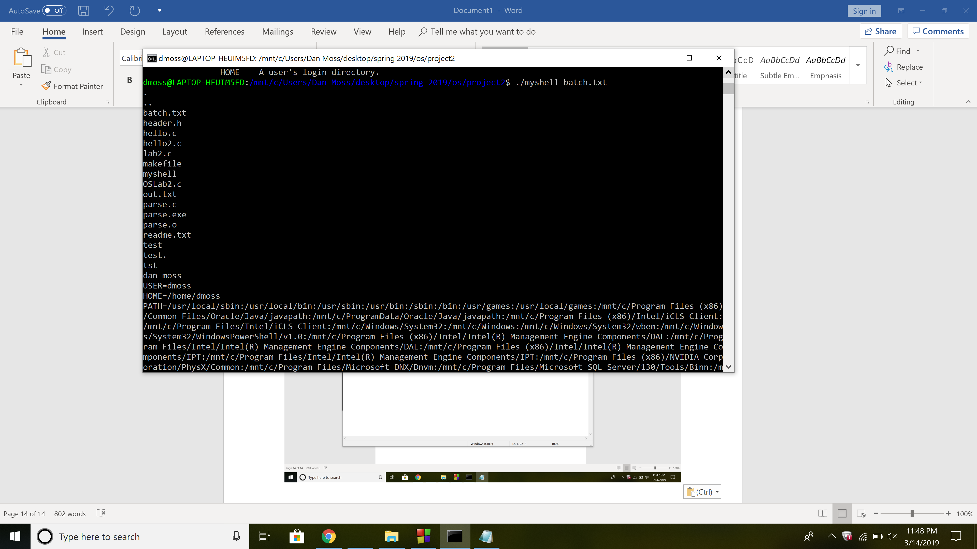

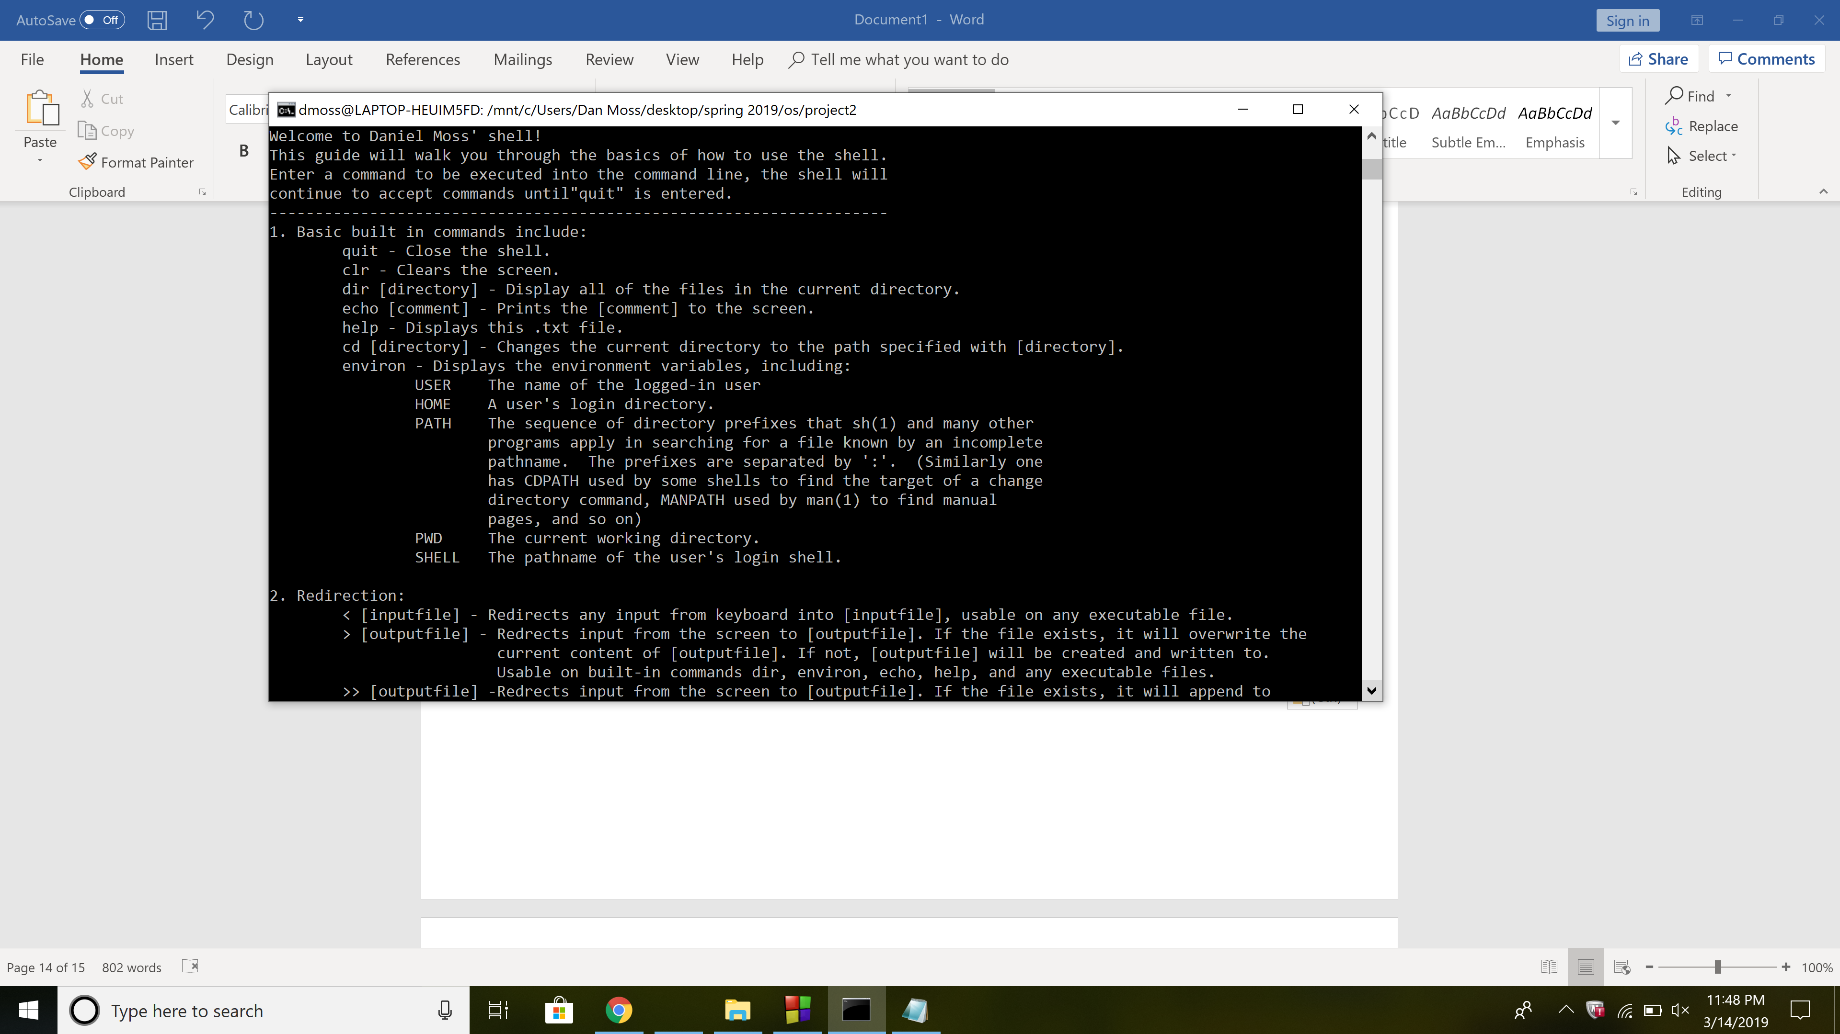

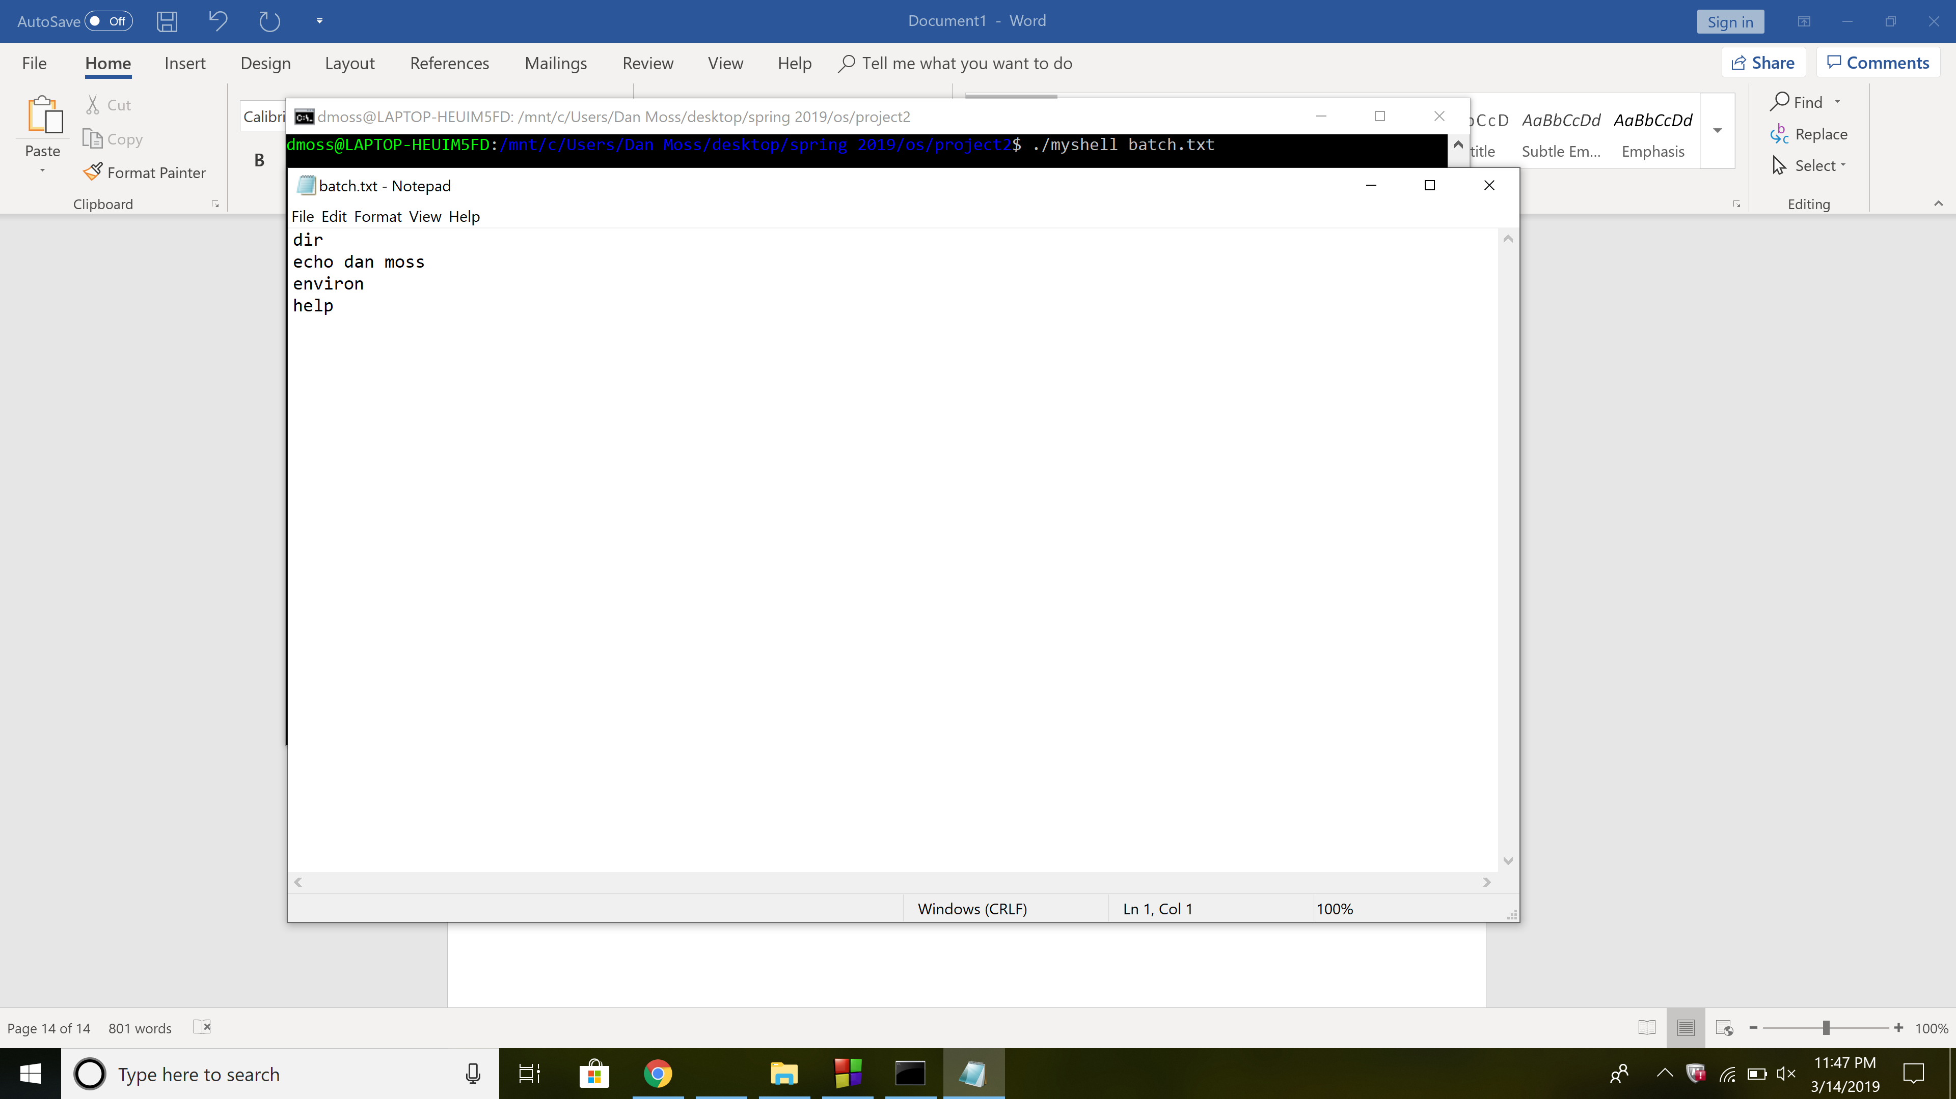

Piping:

int pipefn(char** arg1, char** arg2){

pid_t pid1, pid2;

int fd[2];

//call pipe function to create pipe

pipe(fd);

//fork to execute first program and return pid1

pid1 = fork();

//if pid1 is less than 0 there is an error

if(pid1 < 0) {

printf("Error forking.\n");

}

else if(pid1 == 0) {

//send stdout to the end of the pipe

dup2(fd[1], STDOUT_FILENO);

//close read the end of pipe

close(fd[0]);

execute(arg1);

exit(0);

}

else{

//return to parent process

//fork to execute the second program

pid2 = fork();

if(pid2 < 0) {

printf("Error forking.\n");

}

else if(pid2 == 0) {

//send stdin to read end of pipe

dup2(fd[0], STDIN_FILENO);

//close write end of pipe

close(fd[1]);

execute(arg2);

exit(0);

}

else {

//in parent process and wait for child processes to finish

//close the pipe

close(fd[0]);

close(fd[1]);

//wait for children to finish

waitpid(pid1, NULL, 0);

waitpid(pid2, NULL, 0);

}

}

return 1;

}

